**CODE**

#include<LiquidCrystal.h>

LiquidCrystal lcd(2,3, 4, 5, 6, 7);

int ledpin=13;

int c=1; // led on D13 will show blink on / off

void setup()

{ // put your setup code here, to run once:

Serial.begin(9600);

lcd.begin(16, 2);

Serial.println("Battery Percentage");

pinMode(ledpin,OUTPUT);

}

void loop() {

// put your main code here, to run repeatedly:

char buffer[] = {' ',' ',' ',' ',' ',' ',' '}; // Receive up to 7 bytes

while (!Serial.available()); // Wait for characters

Serial.readBytesUntil('n', buffer, 7);

lcd.clear();

int incomingValue = atoi(buffer);

if ((incomingValue>0)&&(incomingValue<100))

{

Serial.print("Battery: ");

Serial.print(incomingValue);

Serial.println("%");

lcd.setCursor(0,0); //sets the cursor at row 0 column 0

lcd.print("Battery: ");

lcd.print(incomingValue);

lcd.print("%");

digitalWrite(ledpin,HIGH);

delay(1000);

}

if (incomingValue==100)

{

Serial.println("Battery: 100%");

digitalWrite(ledpin,HIGH);

lcd.setCursor(0,0); //sets the cursor at row 1 column 2

lcd.print("Battery: 100%");

delay(10000);

Serial.println("Fully Charged");

lcd.setCursor(0,1); //sets the cursor at row 1 column 2

lcd.print("Fully Charged");

digitalWrite(ledpin,LOW);

delay(1000);

}

}

**RESULT**

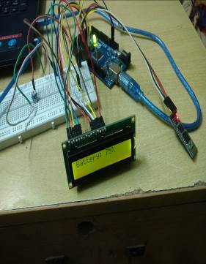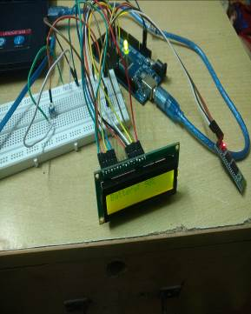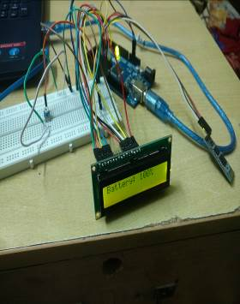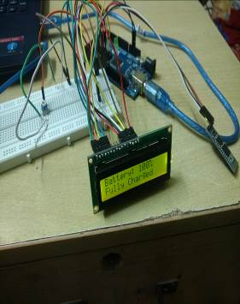

------------------------------------ **THANK YOU** ----------------------------------------